Friday Quiz 17th April 2026
- What music festival has just taken place in the Colorado desert? Coachella
- Where did a Roman Emperor triumph in the north-west last weekend? Aintree. I Am Maximus won the Grand National
- Which island in the Atlantic is known for the sweet, fortified wine produced there? Madeira
- For what specific activity would you be awarded this badge? 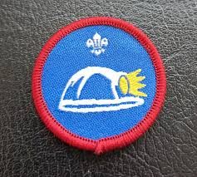 Caving – UK Scouting badge
- Which French 19th century adventure novel tells of a young sailor who becomes an aristocrat after finding a cache of hidden treasure? The Count of Monte Cristo
- Excluding Antarctica, which continent has no island countries? South America
- Which major US political institution has 100 members? The Senate
- Which religious figure was sitting under a tree when they gained enlightenment? The Buddha
- Name the TV show.  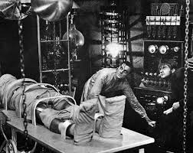 Parks & Recreation. Arlo PARKS and re-creation

- Name the character  Lois Lane (played by Margot Kidder)

- What ‘A’ is the name of the metal (or plastic) thingummy on the end of a shoelace? Aglet
- Name the game 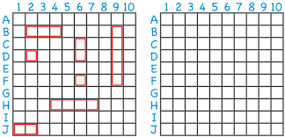 Battleships
- Who was the first explorer to sail from Europe to India by traveling around Africa? Vasco da Gama
- What term is used for the Siberian prison system during the reign of Stalin in the Soviet Union? Gulag
- In which flm does a Fedex employee end up stranded on a desert island? Cast Away
- Change the first letter of a footwear provider to find an aeroplane. Give both words. Farrier & harrier
- Name the film 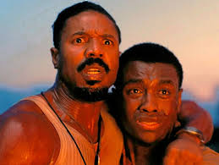 Sinners
- A passcode is made of four characters. The first character is either A, B or C. The second and third characters are different digits. The fourth character is the units digit obtained when adding the second and third characters together. How many different possible passcodes are there? 270. There are 3 possibilities for the first character, 10 possibilities for the second, 9 for the third, and 1 for the fourth, which is determined by the second and third characters. 3 x 10 x 9 x 1 = 270

- What links the pictures? The recent Artemis 2 mission to the moon. Artemis, the goddess of the hunt; the first names of the 4 crew Beryl REID, VICTOR Meldrew, JEREMY Irons, CHRISTINA Aguilera; the Dark Side of the Moon, album by Pink Floyd.
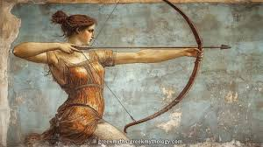
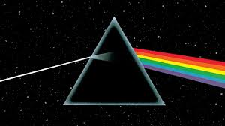

- Unscramble the two words: A A B B F I I I L T U FIBULA & TIBIA

